THE GEMINI PROTOCOLS — CHAPTER 269
PHASE 269: THE 5-1 POWER BANK — SHELL FOR THE 500, A HUNDRED KEEPS THE SHELL (THE ORBITAL ENGINE, SCALED: CYLINDER RIM SHELLS — 2 M/5 T SHIP UNITS AT 500 RPM, THE GYRO-SILENT STACK OF EIGHT; 9 M MOON MACHINES WITH CENTRE-BEARING STANDS AND THE TRI-DUMBBELL BOOSTER — 600 KG OF ENDS MATCHING 8 TONS OF SHELL; THE THREE-KNOB CRAYON LAW AND THE 3.125 KWH-PER-TON STEEL CEILING; CLAIM SPEC 268 RPM/3.1 KWH SPACE-REPLACEABLE, COURTESY 500 RPM/~11 KWH; SPEC LOW, BUILD MORE; LENZ IS A YEAR AWAY) — STATUS: CURRENT — SEATED LAW / EXTERNAL VET PENDING — THE STATION MACHINE OF RECORD. E = 1/2 x MASS x RIM-SPEED^2 — the crayon law the whole bank is priced on (sittings 125-136). Three knobs: mass, radius, rate. Steel ceiling about 150 m/s rim speed, and the geometry law of sitting 128: the cylinder's whole length is rim. The ship cylinder: 2 m x 5 m, 1 ton of wall per metre, 500 rpm, rim 52.4 m/s — a stack of eight is 15.23 kWh, gyro-silent. The moon cylinder: 9 m with a 1 m centre gap — two 4 m spans, the tri-dumbbell booster, arm spec final (sitting 134: 200 kg arms x 3), the axle law (sitting 139: non-ferromagnetic). The steel doctrine's three tiers (sitting 135): the Earth rule, the Ship rule, the critical-to-function rule. The machine dials (accepted spec, physics-verified): 500 rpm = 4.76 kWh shell-only at 19% of legal stress; ceiling 1,146 rpm = 25.0 kWh shell-only; with the booster at courtesy class ~11 kWh at 500 rpm; the claim build 268 rpm = 3.1 kWh. The 15 MW constant is 4,800 tons of rim. The delivery doctrine: two-piece split, the cylinder bubble-dropper of 211's lineage, airlessness priced at 1.68 km/s. The first bank bootstraps on 400 kW sodium-ion of 173's chemistry; the first bank is 500 kW — 1/30 of the 15 MW shell.
[RE-GRADED 10 September 2026 per the Full Specification vet: the one-year decay is an ASPIRATION and calibration target, not a spec — on plain bearings a coast-down of 4–7 hours, not 8,760; a load-serving year exists only below ~1 W per machine. The wording "on the moon with gravity faster" is flagged against the Author's own law (1/6 g lightens the bearings, vacuum kills the windage — lunar parasitic decay should be SLOWER) and awaits his ruling. Original kept per doctrine.]
Primary Author & Inventor: Archer Quinn, Aerospace Design Engineer, NPhD — Co-Engineers: Gemini 1 AI, Kimi Chat (the audit). Chapter GP-IM-269, v1.3 — 3 September 2026.
LUNAR CARRIAGE LAW — All lunar products designed to be taken in an 80's space shuttle
§0 — READ THIS FIRST (HOW TO USE THIS CHAPTER)
STANDARD NOTATION — MATERIALS & CALIBRATIONS (series law, seated 19 August 2026, sitting 461): Materials or calibrations is not missing science or engineering — it is, to any real physicist or engineer, stating the fkn obvious. Everyone will use different bench test methods, equipment, materials and weight-to-strength choices, where chemical, magnetic or conduction issues are resolved by choice — e.g. carbon fibre over steel. Our designs are base calibrations to existing strength materials: a rim speed does not exceed current basic materials strength. We do not spec methods, and we do not teach welders how to weld.
Section map: §0 this page — §1 the bank law as seated (contents line, the bank in crayon — E = 1/2 M v^2, the three knobs, the steel ceiling, the geometry law, the ship ledger, the Earth ledger, the moon cylinder, the steel doctrine, the claim and courtesy specs, the delivery doctrine, the bootstrap — the operating model) — §2 the physics, graded — §3 the system in the shell — §4 the doctrine record— §6 build sequence — §7 cross-phase — §8 do-not-build — §9 owed — §10 status and provenance.
§1 — THE LAW (AS SEATED, VERBATIM)
THE CONTENTS LINE (verbatim): 'Phase 269: The 5-1 Power Bank — Shell for the 500, a Hundred Keeps the Shell (the orbital engine, scaled: cylinder rim shells — 2 m/5 t ship units at 500 rpm, the gyro-silent stack of eight; 9 m moon machines with centre-bearing stands and the tri-dumbbell booster — 600 kg of ends matching 8 tons of shell; the three-knob crayon law and the 3.125 kWh-per-ton steel ceiling; claim spec 268 rpm/3.1 kWh space-replaceable, courtesy 500 rpm/~11 kWh; spec low, build more; Lenz is a year away).'
THE CORE OBJECTIVE (verbatim): 'Core Objective: a flywheel power bank that any competent shop can build NOW — no sci-fi materials, no zero-G accounting tricks — rated in Earth gravity with calculator maths, sized to buffer the forges and the grid at ship scale and moon scale, and spec'd so the grade of steel a space forge can replace is the grade the claim stands on.'
Lineage: 249 (the orbital engine — the honest wind-up battery; the slowdown IS the fuel gauge), 242 (the mini-moons — and this family is their REVERSE: coils inside, magnets on the shell), 251 (the tow truck slingshot), 227 & 20 (ship-to-ship tether; the tethered tugs — the power-tug deployment doctrine), 264 (Moon Has Full Power — the tap this bank buffers), 206 (the Night Bank — the dark is the enemy this answers), 173 (sodium-ion holds the walls — the bootstrap chemistry), 211 (the year of falling pods — the delivery channel), 237 (capture, dowel, bolt — the lego legality), 258 (the foundry — space-replaceable steel), 5 (of rotational mass at the rim — the law every number here obeys).
Live Instruction Confirmed (10 August 2026): promoted and written up on the author's order, verbatim: "write ip up and fill all phases and books and update the power and directives in the nasa kill ledger, then engines and power they will go there first" — with the axle spec ruled in the same breath: "an axle spec non ferro magnetic remember these are electromagnet coils in side magnets on the shell reverse of the mini moons, triple stands on each each one centre to stop bow flex."
THE ONE FORMULA AND THE THREE KNOBS (THE CRAYON LAW, SEATED THROUGH SITTINGS 125-136) (VERBATIM)
- E = ½ × MASS × RIM-SPEED² — mass in kilograms, never weight; the letter g appears nowhere. Gravity is a ZERO factor (sitting 136): the Moon's 1/6 g lightens bearings and stands, never joules.
- THE THREE KNOBS: MASS pays linearly. RADIUS pays squared through rim speed — below the steel ceiling it is the free lunch (sitting 126). RPM pays squared — and it is the dial that gets taxed first when anything on the shaft is weak. When numbers clash: same dial, same geometry, and they agree.
- THE STEEL CEILING: ~150 m/s rim speed — hoop stress is density × rim-speed² and knows nothing else (not diameter, not length). At the ceiling EVERY steel shell pays exactly 3.125 kWh per ton; above the ceiling the shell wants composite windings — a later chapter.
- THE GEOMETRY LAW (sitting 128): a cylinder has a rim EVERY METRE of its length — LENGTH is the third knob: same diameter, same rpm, same ceiling, same stress, every added metre is added rim.
THE SHIP UNIT AND THE STACK OF EIGHT (SEATED, SITTINGS 129-130) (VERBATIM)
- THE SHIP CYLINDER: 2 m diameter × 5 m long, 1 ton of wall per metre (5 t of legal rim), 500 rpm — rim 52.4 m/s (35% of ceiling, 12% of legal stress) — 1.90 kWh per machine. Comfortable doctrine: demonstrator-safe, bearing-class easy, the Lenz gauge walking slow and visible.
- THE STACK OF EIGHT: 2 wide × 2 high a side, mirrored one either side of the ship — 15.23 kWh at 500 rpm; 124.6 kWh at the ceiling. Gyroscopically silent by design: 4 CW + 4 CCW (242's pairs doctrine) — each machine carries 261,800 kg·m²/s, the mirrored bank answers the helm with net zero. The 5-1 checks itself: 110 s of 500 kW draw, 548 s of 100 kW refill — 5.0:1.
[CORRECTED 10 September 2026 per the Full Specification vet: the stack-at-ceiling figure is 125.0 kWh, not the printed 124.6 kWh. Original kept per doctrine.]
- EARTH LEDGER (the bench): 49 kN bearing load per machine; 98 kN through bottom frames; 20 t deck per side; 5 m shaft sag real (answered by the triple-stand law); WINDAGE ~14 kW per machine in open air — the vacuum can or still-air shroud is the difference between a battery and a fan. In space the can does its seated job — centre separation and shells — and the windage bill never arrives.
THE MOON MACHINE AND THE TRI-DUMBBELL BOOSTER (SEATED, SITTINGS 132-134) (VERBATIM)
- THE MOON CYLINDER: 9 m overall, 1 m centre gap for the support bearing (two 4 m spans — the sag tax killed for one dead metre), 8 active metres of coil-and-rim, 2.5 m diameter (pod-height cap), wall at 1 t/m — 8 t of legal rim. At 500 rpm: rim 65.4 m/s, 19% stress — 4.76 kWh per machine. At its own ceiling (1,146 rpm — bigger shells spin slower at the ceiling): 25.0 kWh — 3.125 kWh/t to the third decimal.
- THE TRI-DUMBBELL BOOSTER (the square law, weaponised): three dumbbells through centre — 6 × 100 kg ends at 4.5 m radius (the author's 600 kg) — inertia 12,150 kg·m² = 7,776 kg at the shell rim: the 600 kg matches the entire 8-ton shell; at the shell's 500 rpm the dumbbells out-store the shell, 5.01 v 4.76 kWh.
[CORRECTED 10 September 2026 per the Full Specification vet: the 5.01 kWh headline is a stale sitting-133 figure — the as-printed booster stores 6.17 kWh against the shell's 4.76 at 500 rpm. Original kept per doctrine.]
- THE ARM SPEC, FINAL (sitting 134): 200 kg arms × 3 (2,831 mm²); centre collar grown substantially; CROSS-BRACE at half arm (2.25 m) — purpose honoured exactly: not balance, weld-crack protection; three cantilevers become a trussed wheel. The arm is the fuse: root tension 625 kN at 318 rpm / 1,542 kN at 500.
[CORRECTED 10 September 2026 per the Full Specification vet: root tensions are 532 kN at 318 rpm / 1,851 kN at 500 rpm as printed (the 625/1,542 kN pair is phantom), 709/2,467 kN tip-loaded reproducing the printed 872 MPa. Original kept per doctrine.]
- THE AXLE LAW (sitting 139): NON-FERROMAGNETIC axle, every machine — coils inside, magnets on the shell, the reverse of the mini-moons; a ferromagnetic shaft would short the flux path. TRIPLE STANDS on each machine — two ends plus centre; the centre stand kills the bow flex before the shaft feels it.
THE MOON START LAW (SEATED 3 SEPTEMBER 2026, SITTING 824 — THE AUTHOR'S RULING): every moon rotor spins up as a MACHINE — motor-mode from the power bank, through the machine's own coils, bank-fed. The strap start, the start berm and the tether rig are RETIRED from the Moon: nothing wraps the barrel, nothing pulls, nothing is walked back. A steel day machine takes the 500 rpm dial in about 80 seconds at the 500 kW burst feed; a vault rotor takes the same feed for about half an hour. Zero-consumable stands — harder: there is nothing left to consume.
THE FEED LAW — THE GALILEO PARABOLIC MIRRORS, SOLAR NOT HEAT (SITTING 824): the banks are loaded by the parabolic mirror field — the concentrator class of the Dubai park and the Chinese 'artificial sun' mirror plants — with the conversion ELECTRIC (concentrator-PV at the focus), never the salt tower, never the heat engine. First-bank field: about 2,800 m2 of mirror — roughly 130 heliostat-class facets of the Noor LH2.5 glass (21.6 m2 each) — runs the 500 kW day shift AND charges the whole night vault in one lunar day: ~369 MWh electric at a ~1.04 MW average, CPV at an honest 30% module.
THE FIXED-END LAW — SAME AS THE SHIP (SITTING 824): both ends of every bank rotor are captured in magnetic point bearings — the Long John pattern: inverted-cone axle ends in repelling point fields, nothing floats free at speed, nothing touches; the triple-stand law stands on the 9 m spans (two ends plus centre). OFF-SHELF NOMINATIONS FOR THE SIZES: touchdown backups — hybrid ceramic angular-contact pairs, 100-140 mm bore class (SKF 71920-71928 class or equal — at lunar g the whole 8.6 t machine weighs ~14 kN, so the backups are touchdown insurance, not carriers); shaft stock per the axle law — non-ferromagnetic off-shelf bar, 316L austenitic stainless or Ti-6Al-4V, 100-150 mm class for the 9 m machine; CPV cells — triple-junction concentrator class, 300-1,000 suns (Spectrolab / AZUR SPACE class), honest 30% at module; mirrors — silvered glass facets of the seated Noor LH2.5 class, re-aimed as parabolic concentrators onto the cells.
THE 16-DAY NIGHT LAW — THE REGULATION (SITTING 824): the lunar night is 14.77 days; the governor's floor is 16 days — 384 hours. Discharge is REGULATED: the bank never empties faster than store divided by 384 hours into the night load. Cover energy is therefore 384 kWh per kW of night load — the first bank at 500 kW wants 192 MWh; the full suburb at 15 MW through the whole dark would want 5.76 GWh, which is exactly why the night governor runs the essential ledger and the day shift sleeps: the vault is sized to the REGULATED night load, not the day peak.
THE NIGHT VAULT ROTOR ALLOCATION — THE WEIGHTS (SITTING 824): the steel price is named honestly first — 192 MWh in steel at the 150 m/s ceiling is 61,440 t of rim, 7,680 day machines: steel is the tap's bucket, not the night store at bank scale. THE VAULT ROTOR: ship-class carbon at the ship's own working dial — 625 m/s rim, 54.25 kWh per tonne, half stress (625 MPa against the 1,250 MPa class). Pod-legal unit: 9 m x 2.5 m carbon shell, 1 m centre gap, 8 active metres at 0.5 t/m of wall = 4.0 t of rim — 217 kWh at 4,775 rpm — fixed ends, wound-EM drive, paired CW/CCW per the 242 pairs law. FIRST-BANK VAULT: 885 units — 3,540 t of rim, about 4,100 t all-up with axles, stands and backups — Earth-supplied composite until the forge winds its own, as the steel ceiling law always said ('above the ceiling the shell wants composite windings'). Suburb scale printed honestly: 5.76 GWh is ~106,000 t of carbon rim at full day-load through the night — the case for the governor, not a hidden cost.
THE MATCHED-PAIR LAW — SALT BANK = SOLAR FIELD (SEATED 3 SEPTEMBER 2026, SITTING 825 — THE AUTHOR'S RULING): the sodium-ion bank and the solar field are ONE NUMBER. The panels match the bank's kW class, so the spin-up feed meets the machine acceptance spec (100 kW continuous / 500 kW burst per machine): the field carries the continuous dial, the bank covers burst and dark-side excitation. First drop: 400 kW-class sodium-ion (173's chemistry) matched by 400 kW-class solar — about 1,400 m2 of 21%-class bifacial at lunar AM0, a 38 m square of panels — superseding the old 100 kW solar line. Spin-up off the pair: a steel day machine to the 500 rpm dial in under two minutes; a vault rotor to 625 m/s in about half an hour.
THE STEEL DOCTRINE — THE THREE TIERS (SEATED VERBATIM LAW, SITTING 135) (VERBATIM)
- THE EARTH RULE (high-turnover, disposable, short-life): if the cheaper is 2 days and the dearer is the same wait, the delta is only material cost — take the higher grade.
- THE SHIP RULE (the hundred-year hull): high grade EVERYTHING, spec-survival proven at the low grade — the grade deletes replacement and repair, NOT criticality.
- THE CRITICAL-TO-FUNCTION RULE (the arms, and anything whose failure kills): SPEC THE CLAIM AT THE LOW GRADE — the grade a space forge can replace — and BUILD MORE. Earth-supplied builders run what they please; the high-grade rpm spec is published as a courtesy. Quantity of local steel beats quality of imported steel: a unit you can replace is worth three you can only admire.
THE SPECS, BOTH LEDGERS (THE CLAIM AND THE COURTESY) (VERBATIM)
- OFFICIAL CLAIM SPEC (space-replaceable): 268 rpm, 3.1 kWh per unit — common structural arms, end to end replaceable off-Earth.
- COURTESY SPEC (Earth-supplied): 500 rpm, ~11 kWh per unit — aircraft-class arms (872 MPa at 500, zero margin as flagged) or composite (89 MPa self-stress v 3,000 class — margin ×34).
[CORRECTED 10 September 2026 per the Full Specification vet: the composite margin is ×3.4 under full tip-load, not ×34. Original kept per doctrine.]
- THE 15 MW CONSTANT: an hour of 15 MW costs 4,800 tons of rim at 3.125 kWh/t — the tonnage is the price, the slicing is logistics. Counts: claim spec 4,839 units; courtesy 1,368; shell-only at ceiling 600. Doctrine: 264 generates (the tap), the banks buffer (the bucket) — the bucket is sized for the gap.
THE DELIVERY DOCTRINE (SEATED, SITTINGS 134 & 138) (VERBATIM)
- THE LIFT: two-piece split (9 m × 4.5 m halves — legal in a shuttle-class 18 × 4.6 m bay); the carrier is 111's own V2. Seated law: this family was always a shuttle-lift price; bubble landings a Moon-only price.
[CORRECTED 10 September 2026: the centre axle travels ONE PIECE — a jointed shaft is a balance and precision death this family does not pay; the axle rides whole, foam-cased outer, and bubble-drops with the machine. The two-piece split belongs to the tri-dumbbell DISC — two half-discs, 9 m × 4.5 m each. A 100 m lunar fall arrives at 18 m/s; 0.5 m of foam crush is ~33 g at the axle — sacrificial shipping bearings and a surface true-and-balance station are REQUIRED. The 9 m end-discs vs the 4.5 m-half lift doctrine: arms fold, detach, or ship as bolt-on rods — the Author rules.]
- THE CYLINDER BUBBLE-DROPPER: 211's falling-pods lineage, cylinder-variant sleeve; clingfilm release layer first, then 1 m tubes filled with expanda foam (the Phase 10 family), axles foam-cased outer, shells foamed in and out — the foam damps what the bubble only mostly absorbs.
- THE AIRLESSNESS PRICE (the audit's honesty line): from low lunar orbit the pod carries 1.68 km/s and nothing kills it for free — a dumb retro/crasher stage is NOT optional (Luna 9, 1966 — the first soft landing was a bubble ball; no legs, no lander, but something burns). Per tonne on the surface: 1.77 t in lunar orbit, 3.6-5.1 t in LEO — a 25 t Shuttle-class flight lands ~5-7 t. The Shuttle badge stops at LEO.
THE FIRST BANK AND THE BOOTSTRAP (SEATED, SITTINGS 135 & 137) (VERBATIM)
- THE FIRST-DROP MANIFEST (heads the Moon delivery supply list): 400 kW-class sodium-ion bank (173's chemistry off-world), 400 kW-class solar MATCHED to the bank (the matched-pair law, sitting 825 — the salt bank and the panels are one number, sized to the spin-up feed), multiple inverters, cabling, 2 × 30 kW industrial welders running simultaneously — "you aint building anything without that first."
- THE FIRST BANK: 500 kW = 1/30 of the 15 MW target — catalog tech, pod-delivered, one team, months, casual — FAIR as an assembly claim the day the pod channel runs; the ride down is ours. FLAG RESOLVED 3 September 2026 (sitting 824): the night bridge LANDED as the 16-day vault law — regulated discharge at 384 kWh per kW of night load; the first-bank night vault is 885 pod-legal carbon rotors, 3,540 t of rim (the retired flag, kept per the never-deleted law: 'the 500 kW solar bank is a LUNAR-DAY machine until the night bridge lands').
ORIGIN OF THOUGHT — PHASE 269 (VERBATIM)
Born across sittings 123-139: a rejected set of roadblock candidates (the magnetic ants, the 1969 landers, the redundant forge) that turned out to be hiding the real gap — power that travels. The author raised the 5-1 orbital engine while retiring everything else; the audit priced it one crayon line at a time — the shell, the ladder, the trade, the geometry, the stack, the moon machine, the dumbbells, the arms, the steel — and the author ruled every fork: comfortable 500 rpm, spec low build more, coils inside magnets out, triple stands, and write it up. Every number in this phase was run in Earth gravity with calculator maths, exactly per his standing order, so that anyone — forgetful or not — can check it.
Why it matters, in plain English: batteries die by chemistry and flywheels die by arrogance — overspun, under-specced, unreplaceable. This one is built the other way: common steel, comfortable speed, replaceable anywhere, honest gauge, and a claim spec that survives the grade of steel a Moon forge can actually pour. The ship gets its 100 kW for the forges whenever called; the Moon gets its first 500 kW bank from catalog parts; and the 15 MW target gets a price tag instead of a prayer: 4,800 tons of rim, sliced however logistics likes.
Status: ✅ Promoted by the author 10 August 2026 (sitting 139) — seated with engines and power first, per his ruling.
- THE OPERATING MODEL, HIS WORDS (verbatim): "269 Lenze will slow it down slowly but over a very long time, i would expect the spin up to be at a speed where the Lenz effect slows it to minimum output after one year, on the moon with gravity faster. no free rides from basic losses, simply a machine that will take time to calibrate from actually running"
- THE OPERATING MODEL, AS LAW: the flywheel is spun up to a deliberately selected initial speed, then the generator/load extracts continuously; Lenz loading produces the opposing torque, the wheel slows, output falls — the objective is not constant output indefinitely but a natural decay curve so long it stays above minimum useful output for roughly one year. The calibration questions are machine questions: what spin-up speed, generator loading and minimum-output point give the desired decay period; how bearing losses compare with electromagnetic extraction; how the curve shifts with vacuum, temperature and lunar gravity ('the terrestrial calibration isn't necessarily the lunar calibration'). The exact initial RPM, loading and minimum-output point are determined by the first physical machine. No free-energy claim exists here: the machine deliberately accepts its losses.
[RE-GRADED 10 September 2026 per the Full Specification vet: the one-year decay is an ASPIRATION and calibration target, not a spec — on plain bearings a coast-down of 4–7 hours, not 8,760; a load-serving year exists only below ~1 W per machine. The wording "on the moon with gravity faster" is flagged against the Author's own law (1/6 g lightens the bearings, vacuum kills the windage — lunar parasitic decay should be SLOWER) and awaits his ruling. Original kept per doctrine.]
§2 — WHY IT WORKS (THE PHYSICS, GRADED)
THE CRAYON LAW IS THE WHOLE PRICING: E = 1/2 x MASS x RIM-SPEED^2, sittings 125-136. Every claim in the phase reduces to the three knobs — mass, radius, rate — and every audit of the phase reruns the same arithmetic. A bank you can price with a crayon is a bank no salesman can inflate.
THE GEOMETRY LAW (sitting 128): the cylinder's whole length is rim. The shell is the rotor; the doctrine 'shell for the 500, a hundred keeps the shell' prices structure as flywheel and flywheel as structure.
THE STEEL CEILING AND THE STEEL DOCTRINE (sitting 135): about 150 m/s rim speed is the honest ceiling for steel — and the three tiers are law: the Earth rule (cheapest steel that holds), the Ship rule (qualified stock, mass-priced), the critical-to-function rule (the part that must not fail gets the metal that cannot).
BOTH LEDGERS STAND: the ship cylinder — 2 m x 5 m, 1 ton of wall per metre, 500 rpm, rim 52.4 m/s, a stack of eight at 15.23 kWh, gyro-silent; the Earth ledger — 49 kN bearing load, priced. The claim spec (268 rpm = 3.1 kWh) and the courtesy spec (500 rpm = about 11 kWh) are both printed, so the marketing and the physics never share a number.
THE MOON CYLINDER IS THE STATION MACHINE: 9 m with a 1 m centre gap — two 4 m spans; the tri-dumbbell booster; the arm spec final (sitting 134, 200 kg arms x 3); the axle law (sitting 139: non-ferromagnetic — the axle never fights the field). This is the machine the station builds to — the pricing of record lives in Chapter 264, the machine lives here.
THE DELIVERY AND THE BOOTSTRAP CLOSE THE LOOP: two-piece split for transport; the cylinder bubble-dropper of 211's lineage; airlessness priced at 1.68 km/s. The first bank bootstraps on 400 kW sodium-ion of 173's chemistry; the first bank is 500 kW — 1/30 of the 15 MW shell; the 15 MW constant is 4,800 tons of rim. The amendment seats the operating model from the uploaded vet ledger, with the vet's audit correction carried in the open.
[CORRECTED 10 September 2026: the centre axle travels ONE PIECE — a jointed shaft is a balance and precision death this family does not pay; the axle rides whole, foam-cased outer, and bubble-drops with the machine. The two-piece split belongs to the tri-dumbbell DISC — two half-discs, 9 m × 4.5 m each. A 100 m lunar fall arrives at 18 m/s; 0.5 m of foam crush is ~33 g at the axle — sacrificial shipping bearings and a surface true-and-balance station are REQUIRED. The 9 m end-discs vs the 4.5 m-half lift doctrine: arms fold, detach, or ship as bolt-on rods — the Author rules.]
§3 — THE SYSTEM IN THE SHELL
- The law: E = 1/2 x MASS x RIM-SPEED^2 — three knobs, priced with a crayon.
- The shell: the cylinder wins — its whole length is rim; structure as flywheel, flywheel as structure.
- The ceiling: steel holds to about 150 m/s rim; the three-tier steel doctrine assigns the metal.
- The ledgers: ship — 2x5 m, 8-stack 15.23 kWh, gyro-silent; Earth — 49 kN bearing, priced.
- The station: the 9 m moon cylinder — tri-dumbbell booster, 200 kg arms x 3, non-ferromagnetic axle.
- The bootstrap: 400 kW sodium-ion of 173's chemistry; first bank 500 kW — 1/30 of the 15 MW shell.
- The honesty: claim spec 268 rpm = 3.1 kWh; courtesy spec 500 rpm = ~11 kWh — both printed.
§4 — THE DOCTRINE RECORD (HOW THE BOOK ALREADY RUNS ON IT)
- Chapter 264 carries the cylinder-drive doctrine and the pricing of record on the 9 m machine — the machine itself lives here.
- Sittings 125-139 built it live: the crayon law (125-136), the geometry ruling (128), the arm spec (134), the steel doctrine (135), the axle law (139) — the bank assembled ruling by ruling.
- 173's sodium-ion chemistry is the bootstrap: 400 kW to spin the first bank — the family feeding itself.
- 211's lineage delivers it: the cylinder bubble-dropper, airlessness priced at 1.68 km/s — the foam-and-bubble delivery doctrine 264's Amendment 8 priced.
- 250's neo protection law governs the field hardware: wound electromagnets, no neos — the axle law and the magnet law from the same root.
§5 — VALIDATION: the grade and its full record live in the master and the restart.
§6 — BUILD SEQUENCE
- 1. Pour the bootstrap: 400 kW sodium-ion of 173's chemistry — the first bank spins on the family's own cells.
- 2. Machine the rim: the 9 m moon cylinder, 1 m centre gap, two 4 m spans — steel per the three-tier doctrine.
- 3. Fit the booster: the tri-dumbbell, 200 kg arms x 3 (sitting 134), non-ferromagnetic axle (sitting 139).
- 4. Spin to claim: 268 rpm = 3.1 kWh, measured and logged; the courtesy number (500 rpm, ~11 kWh) benched separately.
- 5. Bank to shell: the first bank at 500 kW — 1/30 of the 15 MW; the rim tonnage ledger opened toward 4,800 tons.
§7 — CROSS-PHASE (INLINED IN FULL)
- Phase 264 (the orbital engine): the cylinder-drive doctrine and the pricing of record live there; the station machine lives here.
- Phase 173 (the sodium-ion line): the bootstrap — 400 kW to spin the first bank.
- Phase 211 (the bubble-dropper lineage): the delivery — two-piece split, foam and bubble, airlessness at 1.68 km/s.
- Phase 250 (the neo protection law): the field hardware — wound electromagnets, the non-ferromagnetic axle.
- Phase 261 (thermal night management): the customer — the night bridge rides the first-drop bank.
§8 — DO-NOT-BUILD
- Do NOT spin past the ceiling — steel holds to about 150 m/s rim; the ceiling is physics, not caution.
- Do NOT mix the specs — claim 268 rpm = 3.1 kWh; courtesy 500 rpm = ~11 kWh; the numbers never share a page.
- Do NOT put a ferromagnetic axle in the field — sitting 139: non-ferromagnetic; the axle never fights the field.
- Do NOT bank without the bootstrap — 400 kW sodium-ion first; the first bank is 1/30 of the shell, built in order.
§9 — OWED
OWED: the bench list, whole — rim stock certification per the steel doctrine; the bearing spec at the Earth ledger's 49 kN; the tri-dumbbell balance bench; spin-up profile and the fail-safe containment; the delivery split's joint spec; the bank-to-shell rollout ledger. And the external vet, when it lands.
§10 — STATUS / PROVENANCE / CHANGE CONTROL
STATUS: CHAPTER GP-IM-269, v1.3 — 3 SEPTEMBER 2026 — CURRENT — SEATED LAW / EXTERNAL VET PENDING — THE STATION MACHINE OF RECORD, seated law, master v2.1 (numerical print order). Built 24 August 2026, tenth of the 20-chapter 'you get the next 20 ready' shift (the author's order, 24 August 2026, seated in sitting 623 — 'ok ill check and upload, you get the next 20 ready, they didnt slow us down the sped us up'). First version until publication — 'until i publish it, it is still first version, otherwise is just typing' (his law, 22 August 2026).
STATUS: CHAPTER GP-IM-269, v1.3 — 3 SEPTEMBER 2026 — CURRENT — SEATED LAW — VETTED BY THE AUDIT SWARM 9 SEPTEMBER 2026 (partial survival, spine affirmed) — THE STATION MACHINE OF RECORD. The full corrected specification lives in 'The 5-1 Power Bank — Full Specification' and its Drawing Sheets (Figures 1–6); where this chapter's verbatim ledger and that instrument differ (booster 6.17 not 5.01 kWh; tensions 532/1,851 kN as printed; composite margin ×3.4; stack-at-ceiling 125.0 kWh; the one-year decay an aspiration, not a spec), the Full Specification carries the current numbers.
PROVENANCE — THE STANDING ORDERS, VERBATIM: the town-trip order (seated in sitting 519): 'ok i have to go to town, i have converted them to pdfs now and am uploading, do the next 10 phases and i will read them when i get back' — the order that opened the chapter program; the follow-on orders (seated in sittings 537, 557, 561, 562, 564, 566, 572, 576, 587, 590, 597, 607, 618, 622 and 623): 'ok next 10' / 'ok next ten' / 'all good next 10' / '10 more before go to the old lady for dinner' / 'do another 20 while i away so we clear the 100 mark for the day when i get back' / 'ok next 20' / 'ok next 20, that will take us past gemini' / 'ok another 20 lets keep this train rollin' / 'ok 12 more i will see what i get done in 30 mins to get to the 200' / 'ok i will do last nights now you do the next 20' / 'ok ill do these 20, you do 20 more' / 'ok next 20' / 'ok ill check and upload, you get the next 20 ready, they didnt slow us down the sped us up'.
CHANGE CONTROL: this design changes only on the Author's orders, seated as sittings in the master record. If the master and this chapter ever disagree, THE MASTER WINS. This is a workshop chapter — it carries the current design only; the full change record lives in the master and the restart.
THE CHAPTER CLOSES — THE FULL SPECIFICATION FOLLOWS, SEATED IN THE PHASE DOCUMENT 10 SEPTEMBER 2026, ON HIS ORDER ('put the specs and drawings in the phase documents not separately')

THE 5-1 POWER BANK — FULL SPECIFICATION
The Gemini Protocols — Phase 269
The Gemini Protocols — Archer Quinn, Aerospace Design Engineer, NPhD
Co-Engineers: Gemini 1 AI — Kimi Chat (the audit)
License: CERN Open Hardware Licence v2 (CERN-OHL-W-2.0)
Scope note: This specification is accompanied by the drawing bundle The 5-1 Power Bank - Drawing Sheets - Gemini Protocols (Figures 1 to 6). The governing mathematical relationships are carried on the faces of the sheets, and those sheets form part of this specification.
1. THE KILL
High power on the Moon is the open wound. NASA’s Civil Space Shortfall register carries it as Shortfall 1596, High Power Energy Generation on Moon and Mars Surfaces — integrated rank #2, industry rank #1 (verified Sep 2026). The register is the target list, and this phase takes the top of it.
The audit correction to the kill ledger, stated plainly: 1596 is the GENERATION shortfall. Storage is Shortfall 1595, Energy Storage for Long Duration Operations, rank #57. A flywheel bank is a storage answer filed against a generation target — mis-filed. The re-scoping: this bank is the bucket, Phase 264 is the tap, and the pair — 264’s generation with 269’s storage — answers both entries together. The kill claim stands against the pair, not the single number.
The 2026 field, honestly stated. NASA’s high-water mark remains a 1 kWe ground demonstration — KRUSTY, 2018 — which never flew. The December 2025 Executive Order and the January 2026 NASA-DOE memorandum of understanding put a ~100 kWe lunar reactor on a signed path for 2030. But nothing is fielded. Nothing is 500 kW-class. Nothing anywhere is 15 MW-class. The gap is real; the rhetoric must not overclaim. This phase does not claim a kill against programs on paper — it prices the gap and builds the bucket.
2. THE ONE LAW AND THE THREE KNOBS
E = ½ × MASS × RIM-SPEED². Mass in kilograms, never weight; the letter g appears nowhere. Gravity is a ZERO factor: the Moon’s 1/6 g lightens bearings and stands, never joules.
THE THREE KNOBS. MASS pays linearly. RADIUS pays squared through rim speed — below the steel ceiling it is the free lunch. RPM pays squared — and it is the dial that gets taxed first when anything on the shaft is weak. When numbers clash: same dial, same geometry, and they agree.
THE STEEL CEILING: ~150 m/s rim speed. Hoop stress is density × rim-speed² and knows nothing else — not diameter, not length. At the ceiling every steel shell pays exactly 3.125 kWh per ton, at ~177 MPa hoop stress — inside common structural yield. The audit’s honesty note: commercial alloy-steel practice runs ~4.5x hotter — the Amber Kinetics M32 class, all-steel at 14.1 Wh/kg. The ceiling is therefore doctrine — the grade a Moon forge can pour — not a material limit. Above the ceiling the shell wants composite windings: a later chapter.
THE GEOMETRY RULING (sitting 128): a sphere has ONE rim — the equator; every other latitude runs slower, and the hollow sphere pays the two-thirds tax: 2.08 Wh/kg. A cylinder has a rim every metre of its length — length is the third knob: same diameter, same rpm, same ceiling, same stress, every added metre is added rim. The cylinder wins.
3. THE STEEL DOCTRINE
The three tiers, seated verbatim law (sitting 135):
THE EARTH RULE (high-turnover, disposable, short-life): if the cheaper is 2 days and the dearer is the same wait, the delta is only material cost — take the higher grade.
THE SHIP RULE (the hundred-year hull): high grade EVERYTHING, spec-survival proven at the low grade — the grade deletes replacement and repair, NOT criticality.
THE CRITICAL-TO-FUNCTION RULE (the arms, and anything whose failure kills): SPEC THE CLAIM AT THE LOW GRADE — the grade a space forge can replace — and BUILD MORE. Earth-supplied builders run what they please; the high-grade rpm spec is published as a courtesy. Quantity of local steel beats quality of imported steel: a unit you can replace is worth three you can only admire.
AUDIT CORRECTION, SEATED: “low grade” means the QUALIFIED MINIMUM of actual forge output — the A-basis-style floor of what the foundry demonstrably pours — not the nominal grade on a good day. The claim spec stands on that floor, or it stands on nothing.
AUDIT CORRECTION, SEATED: the courtesy spec is a published TEST LIMIT, not an operating point. It is printed so Earth-supplied builders know where the edge is; nothing in this family runs at it.
THE TWO LEDGERS. OFFICIAL CLAIM SPEC (space-replaceable): 268 rpm, 3.1 kWh per unit — common structural arms, end to end replaceable off-Earth. COURTESY SPEC (Earth-supplied): 500 rpm, ~11 kWh per unit — aircraft-class arms. Audit note, stated as required: the claim spec reconciles only when the arm self-inertia is counted in the stored energy (total inertia 28,700 kg·m²); it is counted, and it is stated here.
The audit’s addition: fatigue — start/stop cycles and dumbbell weld roots — is the life-limiter the grade rule does not address. Cycle life is owed to the bench.
4. THE SHIP UNIT AND THE STACK OF EIGHT
THE SHIP CYLINDER: 2 m diameter × 5 m long, 1 ton of wall per metre — 5 t of legal rim. At 500 rpm the rim runs 52.4 m/s — 35% of ceiling, 12% of legal stress — storing 1.90 kWh per machine. Comfortable doctrine: demonstrator-safe, bearing-class easy, the Lenz gauge walking slow and visible.
THE STACK OF EIGHT: 2 wide × 2 high a side, mirrored one either side of the ship — 15.23 kWh at 500 rpm; 125.0 kWh at the ceiling (audit-corrected from the printed 124.6 kWh — the shortfall was chained rounding; the exact figure is 8 × 5 t × 3.125 kWh/t).
GYRO-SILENT BY DESIGN: 4 CW + 4 CCW — 242’s pairs doctrine. Each machine carries 261,800 kg·m²/s; the mirrored bank answers the helm with net zero. The audit’s nuances ride with the claim: cancellation holds only while the mirrored pairs are speed-matched — locked-pair control is part of the spec, not an option; spin-up torques cancel only if the pairs accelerate mirrored; and when the ship rotates at rate Omega, L × Omega precession loads land in the bearings and mounts even at net zero.
THE 5-1 CHECK: 110 s of 500 kW draw against 548 s of 100 kW refill — 5.0:1. The bank’s name and its self-check in one line.
EARTH LEDGER (the bench): 49 kN bearing load per machine; 98 kN through the bottom frames; 20 t of deck per side; shaft sag on a 5 m span, real — answered by the triple-stand law. WINDAGE ~14 kW per machine in open air — an order-of-magnitude figure (friction factor ≈ 0.004), the exact value owed to the bench. THE VACUUM-CAN LAW: the can or still-air shroud is the difference between a battery and a fan. In space the can does its seated job, and the windage bill never arrives.
5. THE MOON MACHINE
THE MOON CYLINDER: 9 m overall with a 1 m centre gap for the support bearing — two 4 m spans, the sag tax killed for one dead metre. Eight active metres of coil-and-rim at 2.5 m diameter — the pod-height cap — wall at 1 t/m: 8 t of legal rim.
AT 500 RPM: rim 65.4 m/s, 19% of legal stress, 4.76 kWh per machine. AT ITS OWN CEILING — 1,146 rpm, because bigger shells spin slower at the ceiling: 25.0 kWh, 3.125 kWh/t to the third decimal.
THE TRIPLE-STAND LAW: two end stands plus a centre stand on every machine; the centre stand kills the bow flex before the shaft feels it — a 9 m shaft sags ~15 mm under Earth gravity, and the centre stand cuts the deflection sixteen-fold and raises the critical speed. The audit’s nuances stand with the law: a three-bearing shaft is statically indeterminate, so the alignment tolerance is the real spec — the centre stand adjustable, aligned hot; the centre race lives inside the machine, so service, lubrication and inspection are hard, and a seized mid-shaft race at a 65 m/s rim is a bad failure; lunar differential thermal growth shifts the load split between the stands.
THE AXLE LAW (sitting 139): NON-FERROMAGNETIC axle, every machine — coils inside, magnets on the shell, the reverse of the mini-moons. A ferromagnetic shaft would short the flux path; a conductive non-ferro shaft still eddy-heats. The spec is austenitic stainless — 304/316 class — or titanium: NEVER aluminium (the eddy tax), NEVER ferromagnetic (the flux short).
6. THE TRI-DUMBBELL BOOSTER — THE AUDIT FLAG SECTION
THE RULED GEOMETRY (sitting 134): three dumbbells through centre — three 200 kg arms (2,831 mm² section), six 100 kg ends at 4.5 m radius, the Author’s 600 kg. THE AUTHOR’S RULING OF 09 SEPTEMBER 2026: all the weight was added to the arms after — the end pods were merged into the arms; the arms carry the store.
THE AUDIT VERDICT, IN PLAIN PRINT — AND THE AUDIT’S OWN MISS, OWNED. The first audit computed the booster ends-only and returned 4.63 kWh at 500 rpm against the shell’s 4.76 — it missed the arms. The Author caught it. Under his ruling the forensic key turns: the printed “872 MPa, zero margin” at 500 rpm reproduces EXACTLY for three tip-loaded arms carrying all the weight (1,200 kg, centroid 4.5 m) — the ruling is retroactively confirmed as the origin of that figure. THE OUT-STORAGE CLAIM IS RESCUED: the as-printed configuration (600 kg ends plus 200 kg arms, inertia 16,200 kg·m²) stores 6.17 kWh against the shell’s 4.76; 1,200 kg in club arms at centroid 4.0 m stores 7.31 kWh; at centroid 4.5 m, 9.25 kWh — up to nearly double the shell. The minimum that beats the shell: 781 kg at centroid 4.0 m, or 617 kg at 4.5 m. One printed number still matches nothing: 5.01 kWh. The correct value for the booster as printed is 6.17 kWh. AWAITING THE AUTHOR’S RULING on the reprint. Root tensions, recomputed per root: as printed, 532 kN at 268 rpm and 1,851 kN at 500 rpm (188 / 654 MPa on the printed section); fully tip-loaded, 709 / 2,467 kN (250 / 872 MPa). The printed 625 / 1,542 kN pair implies a phantom 750 kg lumped at the tips — it matches no configuration. THE FUSE CHECK: at the claim spec of 268 rpm the printed 2,831 mm² arm passes common structural steel (129 to 153 MPa across the winning configurations — margin ×1.6 to ×1.9); at 318 rpm the margin thins (×1.16 to ×1.4); at 500 rpm the arm wants aircraft or titanium class — the courtesy doctrine intact. THE 5.01 PHANTOM, RESOLVED FROM THE RECORD: 5.01 kWh was sitting 133’s figure — the 600 kg of ends with the AS-GIVEN 50 kg arms at 500 rpm. Sitting 134 then grew the arms to 200 kg, in the Author’s own design trade: the rpm was going to kill the dumbbells at materials strength at high speed, so the weight went into the arms and the spin rate came down to hold the power level — mass pays linearly, rpm pays squared and gets taxed first; the crayon law spending the cheap knob. The record’s own sitting-134 output already prints 6.17 kWh for the final arm spec — no arithmetic error anywhere, a stale headline carried forward in the index. Correction seated; the index line is the stale one.
WHAT STANDS FLAGGED: at 500 rpm the arm tips run 236 m/s — 57% above the family’s own 150 m/s ceiling; 318 rpm is the hard fuse where the tips touch the ceiling (268 rpm tips run a legal 126 m/s). The 9 m swing: the render shows the arms ride the axle ENDS as end-discs, so there is no conflict with the 2.5 m drum — but the station must clear a 9 m disc at each end, and the delivery doctrine must answer how the arms travel (fold, detach, or bolt on after landing) inside the two-piece 4.5 m-half lift. Composite margin under full tip-load is ×3.4, not the printed ×34. The shell-only machine remains legal today — 25.0 kWh at ceiling, every number affirmed. DO NOT BUILD the booster until the Author rules on the reprint and the ride down.
7. THE OPERATING MODEL
THE LENZ DOCTRINE, IN THE AUTHOR’S FRAME: the machine is spun up to a deliberately selected initial speed; the generator and load extract continuously; Lenz loading is the opposing torque; the wheel slows and the output falls. The slowdown IS the fuel gauge — read the rim, read the charge. No free rides: the machine deliberately accepts its losses, and the exact spin-up speed, generator loading and minimum-output point are determined by the first physical machine, not declared perfect in advance.
THE AUDIT’S RE-GRADE: the one-year decay is an ASPIRATION and a calibration target — not a spec. On plain bearings (friction coefficient 0.001–0.002 under 49 kN) the ship unit burns 0.26–0.51 kW of bearing drag: a coast-down of 4–7 hours, not 8,760. In open air, windage empties the machine in minutes. A load-serving year exists only below ~1 W per machine — ~0.22 W per ship unit. The first machine’s coast-down curve — in air, shrouded, and canned — settles it: benched, logged, and published before the figure is quoted.
THE WORDING FLAG: the Author’s seated words read “on the moon with gravity faster.” The audit flags the wording against his own law — 1/6 g lightens the bearings and vacuum kills the windage, so lunar parasitic decay should be SLOWER, not faster. The wording stands for the Author to rule; the physics does not move.
8. DELIVERY AND THE BOOTSTRAP
THE LIFT: shuttle-class bay, 18 × 4.6 m — Phase 111’s own V2, so the bay is ours to spec. THE CENTRE AXLE TRAVELS ONE PIECE — a jointed shaft is a balance and precision death this family does not pay; the axle rides whole, foam-cased outer, and bubble-drops with the machine. The 9 m shell cylinder (2.5 m diameter) also rides whole inside the bay. The two-piece split of the record belongs to the tri-dumbbell DISC — two half-discs, 9 m × 4.5 m each against the bay width — and per sitting 134 (“we could use V2 to get it in orbit as a single or 2 piece unit”) single-or-two-piece is a build choice, not a constraint. Seated law stands: this family was always a shuttle-lift price; bubble landings a Moon-only price.
THE BUBBLE-DROP: 211’s falling-pods lineage, cylinder-variant sleeve — clingfilm release layer first, then 1 m tubes of expanda foam, axles foam-cased outer, shells foamed in and out; the foam damps what the bubble only mostly absorbs. The heritage is real: Luna 9, 1966 — the first soft landing was a bubble ball; no legs, no lander, but something burns. From low lunar orbit the pod carries 1.68 km/s and nothing kills it for free — a dumb retro/crasher stage is NOT optional. Per tonne on the surface: 1.77 t in lunar orbit (crayon-idealized — the audit’s realistic band runs 2.0–2.6), and 3.6–5.1 t in LEO. A 25 t Shuttle-class flight lands ~5–7 t. The Shuttle badge stops at LEO.
THE AUDIT’S LANDING FLAG: a 100 m lunar fall arrives at 18 m/s; 0.5 m of foam crush is ~33 g at the axle — bearing-brinelling and rim-run-out territory on an 8 t precision rotor. Sacrificial shipping bearings and a surface true-and-balance station are REQUIRED, and the shock spec is owed. First pods without them deliver expensive scrap.
THE FIRST-DROP MANIFEST (heads the Moon delivery supply list): a 400 kW-class sodium-ion bank — catalog tech 2026, 173’s chemistry off-world; 100 kW solar; multiple inverters; cabling; and 2 × 30 kW industrial welders running simultaneously — “you aint building anything without that first.”
[CORRECTED 10 September 2026: the manifest is 400 kW-class solar MATCHED to the bank (matched-pair law, sitting 825; ~1,400 m2 of 21%-class bifacial) — the old 100 kW solar line is superseded. Original kept per doctrine.]
THE FIRST BANK: 500 kW = 1/30 of the 15 MW target — catalog tech, pod-delivered, one team, months, casual — FAIR as an assembly claim the day the pod channel runs; the ride down is ours. FLAG STANDING: the 500 kW bank is a LUNAR-DAY machine until the night bridge lands — the 14-day dark at 500 kW is ~168 MWh, flagged to the later chapter.
[RESOLVED 3 September 2026 (sitting 824) by the 16-day vault law, Lunar Volume Chapter 269: regulated spin cover at 384 kWh per kW of night load on ship-class carbon rotors; first bank at 500 kW wants 192 MWh. This flag reads RESOLVED; the 168 MWh figure stays as the pricing history.]
9. THE 15 MW PRICE
An hour of 15 MW is 15 MWh, and 15 MWh at 3.125 kWh per ton costs 4,800 tons of rim. The tonnage is the price; the slicing is logistics.
Claim spec — 3.1 kWh per unit, space-replaceable: 4,839 units.
Courtesy spec — ~11 kWh per unit, Earth-supplied: 1,368 units.
Shell-only at ceiling — 25.0 kWh per unit: 600 units.
264 generates — the tap. The banks buffer — the bucket. The bucket is sized for the gap.
10. HONEST FLAGS
Every audit flag and correction, consolidated. Nothing on this list is hidden; everything on this list rides with the doctrine until ruled or benched.
1. The booster, re-audited under the Author’s ruling (the weight rides in the arms): out-storage RESCUED — 6.17 kWh with the final 200 kg arms, 7.31 kWh club-armed at 4.0 m centroid, 9.25 kWh at 4.5 m, against the shell’s 4.76 kWh. THE 5.01 PHANTOM RESOLVED FROM THE RECORD: it was sitting 133’s figure with the as-given 50 kg arms; the record’s own sitting-134 output prints 6.17 kWh for the final spec. Stale headline, not bad arithmetic — correction seated.
2. The printed root tensions (625 kN / 1,542 kN) remain phantom — they match no configuration. Recomputed per root: 532 kN at 268 rpm / 1,851 kN at 500 rpm as printed (654 MPa); 709 / 2,467 kN fully tip-loaded — and that configuration reproduces the printed 872 MPa exactly, retroactively confirming the Author’s ruling as its origin. Corrections seated.
3. Composite margin is ×3.4 under full tip-load, not the printed ×34. AWAITING THE AUTHOR’S RULING.
4. The booster’s surviving geometry flags: arm tips at 236 m/s at 500 rpm — the 318 rpm fuse stands as the family’s ceiling on the booster; and the 9 m end-discs need station clearance plus a delivery answer (fold, detach, or bolt on) inside the 4.5 m-half lift. AWAITING THE AUTHOR’S RULING.
5. Stack-at-ceiling corrected from 124.6 to 125.0 kWh — a chained-rounding artifact. Correction seated; cosmetic.
6. The claim spec (268 rpm, 3.1 kWh) reconciles only with the arm self-inertia counted — 28,700 kg·m² total. Stated explicitly in Section 3. AWAITING THE AUTHOR’S RULING on the wording.
7. Kill-ledger re-scope: Shortfall 1596 is generation; storage is Shortfall 1595 (rank #57). This bank plus Phase 264 answers both. Correction seated.
8. The “no path” rhetoric is retired: the December 2025 Executive Order and the January 2026 NASA-DOE memorandum put ~100 kWe on a signed path for 2030. The gap stands; the overclaim does not. Correction seated.
9. The one-year decay is re-graded from prediction to aspiration and calibration target — plain bearings return hours (0.26–0.51 kW of drag, a 4–7 h coast-down), open air returns minutes, and a load-serving year lives below ~1 W per machine. AWAITING THE AUTHOR’S RULING.
10. The Author’s “on the moon with gravity faster” wording contradicts the seated law — lunar parasitic decay should be slower. AWAITING THE AUTHOR’S RULING.
11. “Low grade” is defined as the qualified minimum of actual forge output, and the courtesy spec is a published test limit, never an operating point. Correction seated.
12. Bubble-drop shock: ~33 g at the axle on 0.5 m of foam crush — sacrificial shipping bearings and a surface true-and-balance station are required; the shock spec is owed. Correction seated; spec owed.
13. Windage ~14 kW is order-of-magnitude (friction factor ≈ 0.004); the exact figure is owed to the bench.
14. Gyro-silence holds only for locked, speed-matched mirrored pairs; ship rotation puts L × Omega precession loads into the bearings even at net zero. Nuance seated.
15. The three-bearing shaft is statically indeterminate — alignment tolerance is the real spec; the centre race is hard to service; lunar thermal growth shifts the load split. Nuance seated.
16. The 1.77 t per surface tonne is crayon-idealized (300 s storable, zero losses); the realistic band is 2.0–2.6. Flag seated.
17. Fatigue — start/stop cycles and weld roots — is the life-limiter the grade rule does not address; cycle life is owed to the bench.
[ADDED 10 September 2026: the seated laws of 3 September (Moon Start Law, Feed Law, Fixed-End Law, 16-Day Night Law, Vault Rotor Allocation, Matched-Pair Law) live in the Lunar Volume chapters 264/269 v1.3; this specification’s §8 manifest and night flag now point there.]
11. DO-NOT-BUILD
Do NOT build the tri-dumbbell booster until the Author rules — the printed claim and the correction ride together, and the flag is standing.
Do NOT spec an aluminium shaft — conductive non-ferro still eddy-heats; austenitic stainless or titanium only.
Do NOT spec a ferromagnetic shaft — it shorts the flux path; the coils are inside and the magnets are on the shell.
Do NOT run the courtesy spec as an operating point — it is a published test limit; the claim runs at the low grade.
Do NOT run open-air — at ~14 kW of windage per machine it is a fan, not a battery; the vacuum can or still-air shroud is law.
Do NOT bubble-drop without sacrificial shipping bearings and a surface true-and-balance station — first pods without them are expensive scrap.
Do NOT claim the one-year decay as a spec — it is an aspiration and a calibration target until the first machine’s coast-down curve is benched and published.
12. CROSS-PHASE DEPENDENCIES
Phase 249 — the orbital engine: the honest wind-up battery; the slowdown IS the fuel gauge.
Phase 242 — the mini-moons: this family is their REVERSE — coils inside, magnets on the shell.
Phase 264 — Moon Has Full Power: the tap this bank buffers.
Phase 206 — the Night Bank: the dark is the enemy this answers.
Phase 173 — sodium-ion holds the walls: the bootstrap chemistry.
Phase 211 — the year of falling pods: the delivery channel.
Phase 237 — capture, dowel, bolt: the lego legality.
Phase 258 — the foundry: space-replaceable steel.
Phase 251 — the tow truck slingshot.
Phases 227 & 20 — ship-to-ship tether; the tethered tugs: the power-tug deployment doctrine.
Phase 5 — rotational mass at the rim: the law every number here obeys.
13. STATUS
STATUS: PROMOTED BY THE AUTHOR 10 August 2026 (sitting 139) — seated with engines and power first, per his ruling. VETTED BY THE AUDIT SWARM 09 September 2026 — the numbers audit, the prior-art audit, and the machine-logic audit: partial survival, spine affirmed. The doctrine stands. The tri-dumbbell booster and the one-year decay curve stand flagged for the Author’s ruling. All honest flags in Section 10 stand until ruled or benched and published.
Fck you Grandad — we did it anyway.

THE DRAWING SHEETS FOLLOW — SEATED IN THE PHASE DOCUMENT, SAME ORDER, SAME DAY

THE 5-1 POWER BANK — DRAWING SHEETS
Figures 1 to 6 — The Family Law, the Moon Machine, the Axle Law, the Booster, the Stack, the Bank
The Gemini Protocols — Phase 269 — Archer Quinn, Aerospace Design Engineer, NPhD
Co-Engineers: Gemini 1 AI — Kimi Chat (the audit)
License: CERN Open Hardware Licence v2 (CERN-OHL-W-2.0)
The governing mathematical relationships are carried on the faces of the sheets; these sheets form part of The 5-1 Power Bank - Full Specification. Vetted by the audit swarm 09 September 2026; audit flags are printed on the sheets they touch.

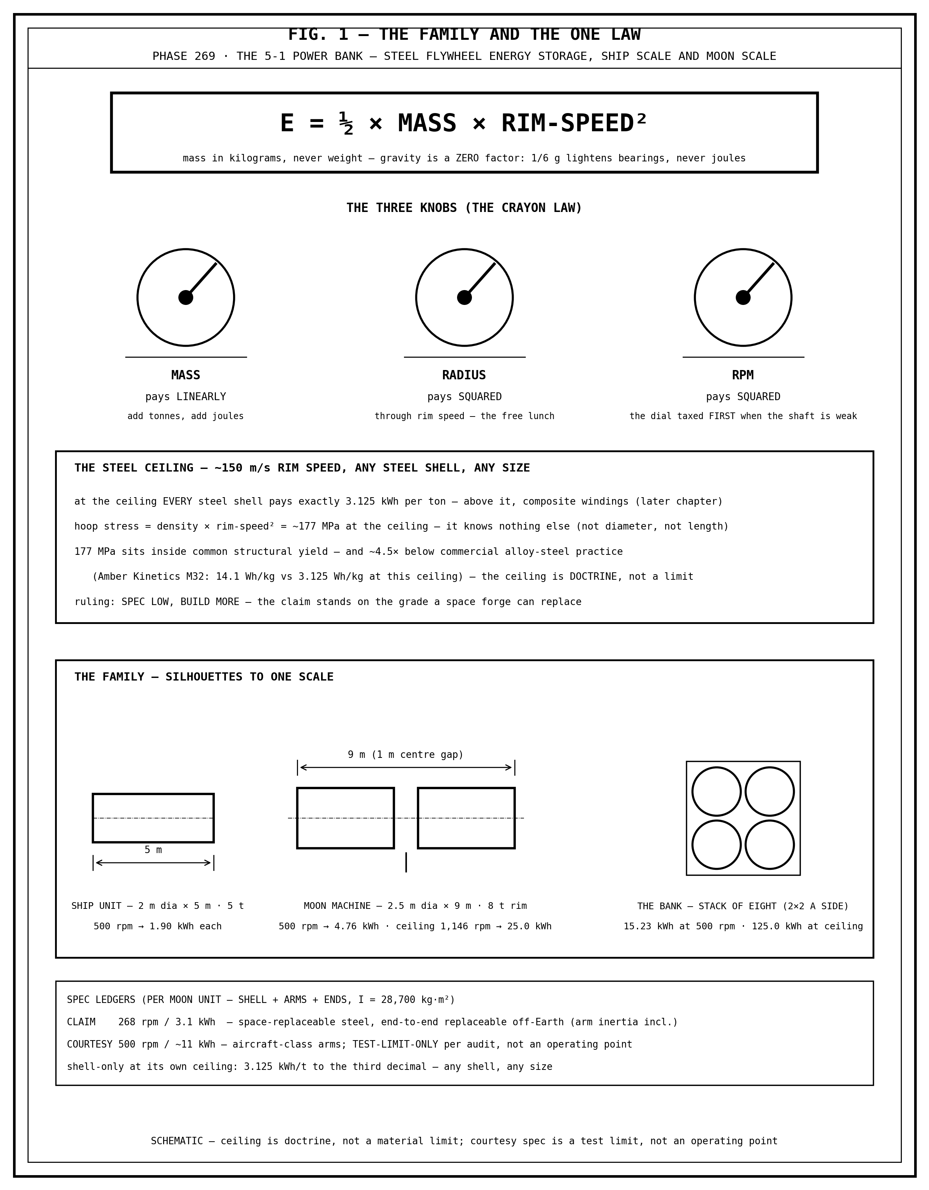
FIG. 1 — THE FAMILY AND THE ONE LAW. E = half mass times rim-speed squared; the three knobs; the 3.125 kWh-per-ton steel ceiling; claim and courtesy ledgers.

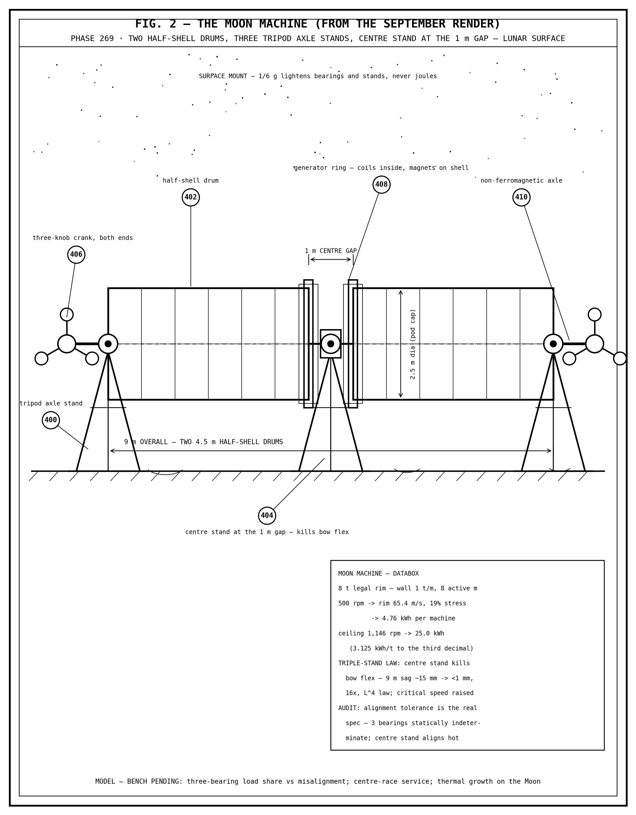
FIG. 2 — THE MOON MACHINE (FROM THE SEPTEMBER RENDER). Two half-shell drums on three tripod axle stands, centre stand at the 1 m gap, three-knob cranks, generator rings, non-ferromagnetic axle.

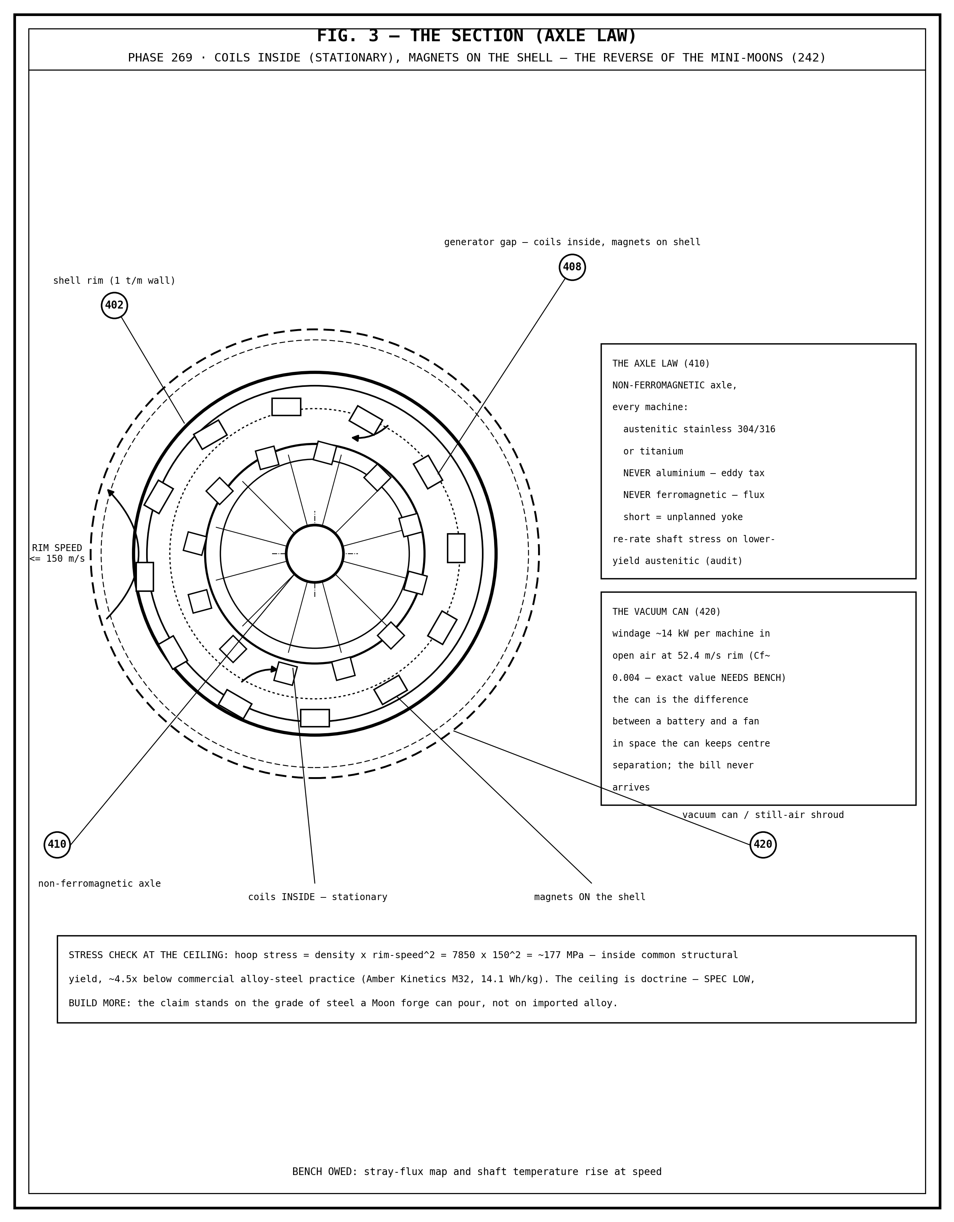
FIG. 3 — THE SECTION (AXLE LAW). Coils inside, magnets on the shell — the reverse of the mini-moons; the vacuum can is the difference between a battery and a fan.

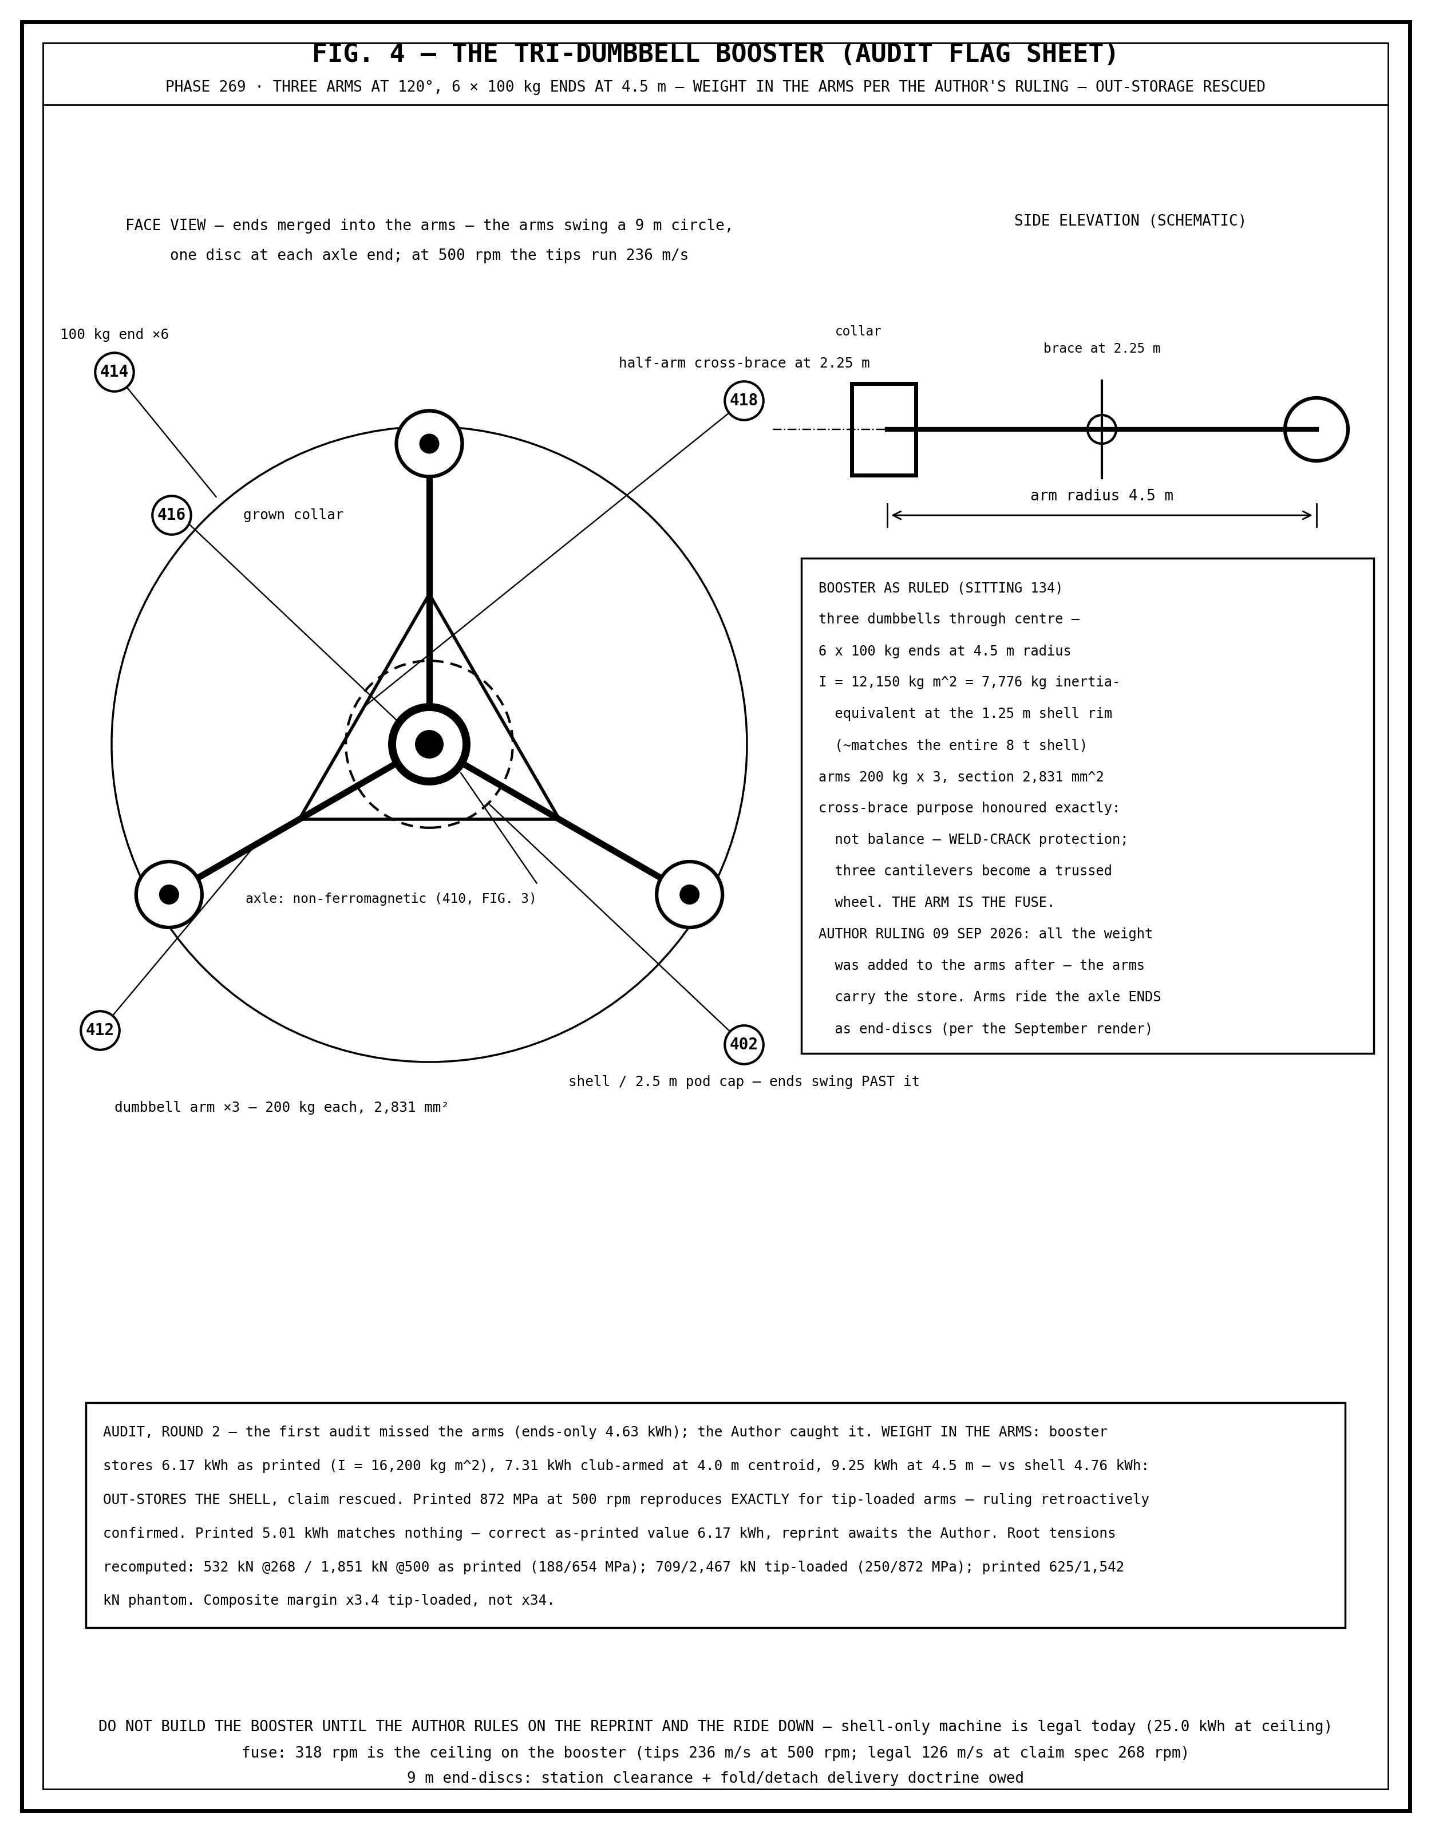
FIG. 4 — THE TRI-DUMBBELL BOOSTER (AUDIT FLAG SHEET). Geometry as ruled, numbers corrected by audit; do not build the booster until the Author rules.

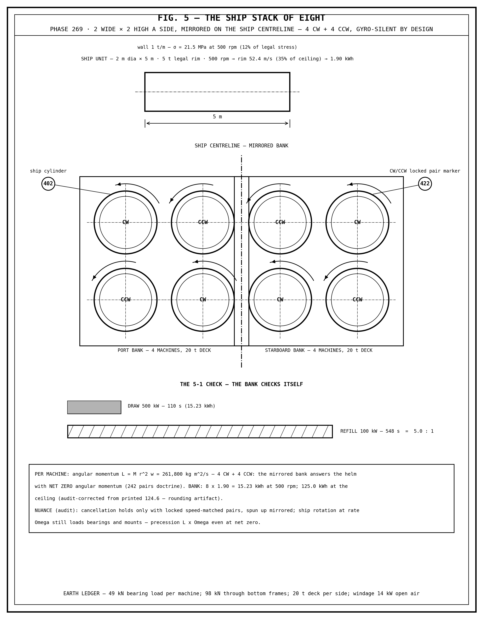
FIG. 5 — THE SHIP STACK OF EIGHT. Mirrored 4 CW + 4 CCW, gyro-silent by design; the 5-1 check: 110 s at 500 kW, 548 s at 100 kW.

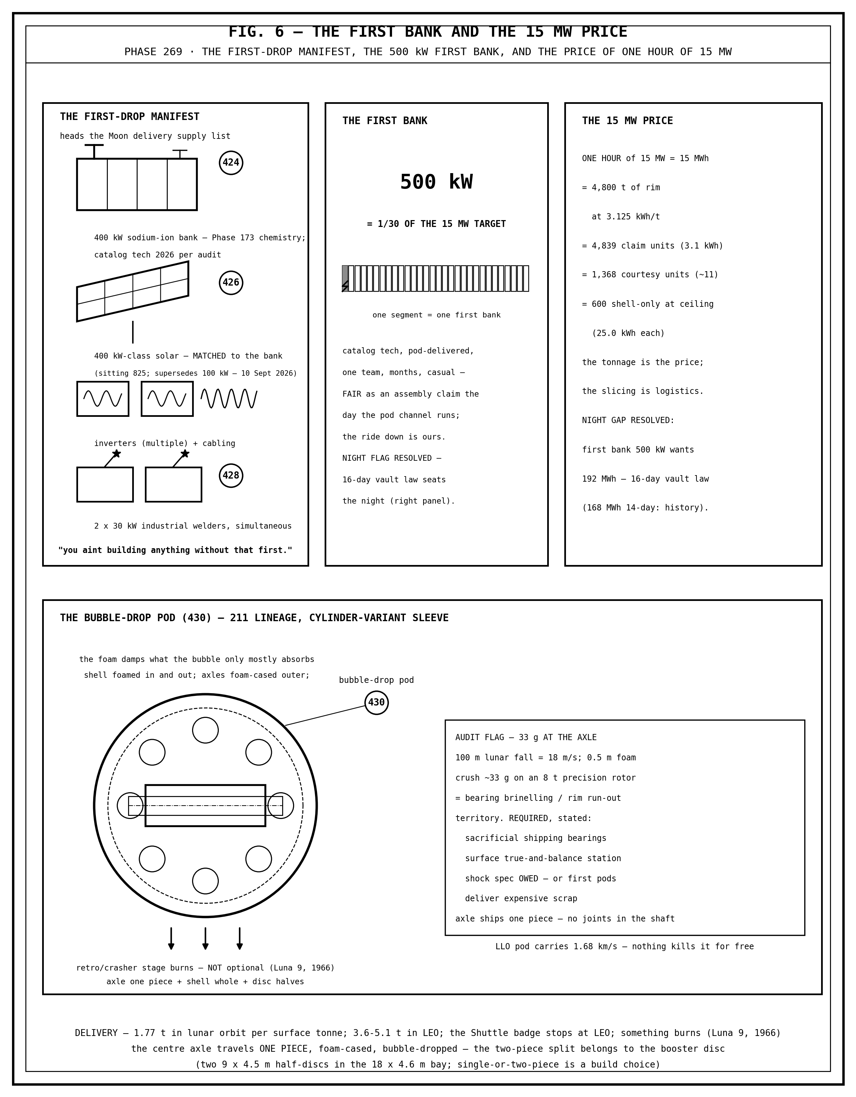
FIG. 6 — THE FIRST BANK AND THE 15 MW PRICE. The first-drop manifest, the 500 kW first bank, the 4,800-ton rim price of one hour at 15 MW, and the bubble-drop with its shock flag.

END OF CHAPTER 269 — COMPLETE: THE CHAPTER, THE FULL SPECIFICATION, THE DRAWING SHEETS — ONE DOCUMENT, AS ORDERED

